INSTRUCTIONS to prepare AN EXTENDED ABSTRACT FOR THE
32nd International Conference on PARALLEL COMPUTATIONAL FLUID DYNAMICS – Parcfd'2020
First A. Author*, Second B. Author† and Third C. Coauthor†
* MINES ParisTech PSL University
Department of Mechanical Engineering
06904 Sophia Antipolis, FRANCE
e-mail: first.author@mines-paristech.fr, web page: https://www.hpc-ai.mines-paristech.fr

† Claude Bernard Lyon 1 University
Polytech Engineering School
06622 Lyon, FRANCE
Email: second.author@univ-lyon1.fr - Web page: https://cdcsp.univ-lyon1.fr
Key words: CFD methodology, Parallel methodology, Parallel CFD applications.
Summary. This document provides information and instructions for preparing an Extended Abstract to be included in the Proceedings of Parallel CFD2020 Conference.

1 INTRODUCTION
The Conference publication will consist of a hard-printed book containing Extended Abstracts of the contributions received. Authors should submit the Extended Abstract electronically via the web page of the Conference before the deadline announced. The Extended Abstract should be written following the format of Word macros for submission that can be found in that address. The file has to be translated into Portable Document Format (PDF) before submission via the Conference site. The organizers do not commit themselves to include in the Proceedings any Extended Abstract received later than the above-mentioned deadline. The speaker and the contact author should match.

2 GENERAL SPECIFICATIONS
The Extended Abstract must be written in English within a printing box of 16cm x 21cm, centered in the page. The Extended Abstract including figures, tables and references must not exceed pages. Maximum file size is 2 MB.

3 TITLE, AUTHORS, AFFILIATION, KEY WORDS
The first page must contain the Title, Author(s), Affiliation(s), Key words and the Summary. The Introduction must begin immediately below, following the format of this template.
3.1 Title
The title should be written centered, in 14pt, boldface Roman, all capital letters. It should be single spaced if the title is more than one line long.
3.2 Author
The author's name should include first name, middle initial and surname. It should be written centered, in 12pt boldface Roman, 12pt below the title.
3.3 Affiliation
Author's affiliation should be written centered, in 11pt Roman, 12pt below the list of authors. A 12pt space should separate two different affiliations.
3.4 Key words
Please, write no more than six key words. They should be written left aligned, in 12pt Roman, and the line must begin with the words Key words: boldfaced. A 12pt space should separate the key words from the affiliations.
3.5 Summary
Use 12pt Italic Roman for the summary. The word Summary must be set in boldface, not italicized, at the beginning of the first line. The text should be justified and separated 12pt from the key words, as shown in the first page of these instructions.

4 HEADINGS
4.1 Main headings
The main headings should be written left aligned, in 12pt, boldface and all capital Roman letters. There should be a 12pt space before and 6pt after the main headings.
4.2 Secondary headings
Secondary headings should be written left aligned, 12 pt, boldface Roman, with an initial capital for first word only. There should be a 12pt space before and 6pt after the secondary headings.
5 EDITORIAL HEADING
The first page has to include the Editorial Heading, as shown in the first page of these instructions. Successive pages will include the name of the authors.
6 TEXT
The normal text should be written single-spaced, justified, using 12pt (Times New) Roman in one column. The first line of each paragraph must be indented 0.5cm. There is not inter-paragraph spacing.
7 PAGE NUMBERS
In order to organize the Extended Abstract, it is better to number the pages. Page numbers are not included in the printing box.
8 FIGURES
All figures should be numbered consecutively and captioned. The caption title should be written centered, in 10pt Roman, with upper and lower case letters.

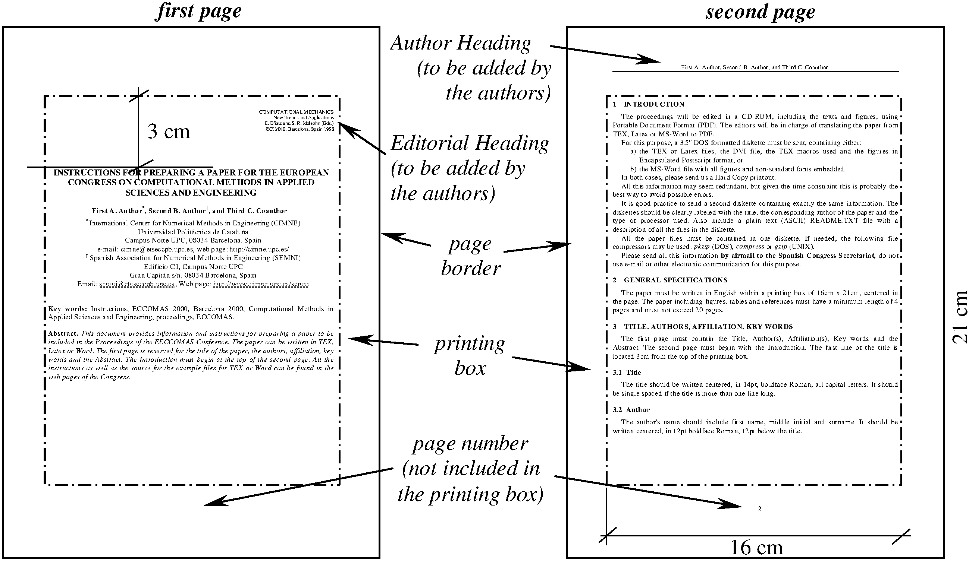

Figure 1: Page layout
A 6pt space should separate the figure from the caption, and a 12pt space should separate the upper part of the figure and the bottom of the caption from the surrounding text.
Figures may be included in the text or added at the bottom of the Extended Abstract.
9 EQUATIONS
A displayed equation is numbered, using Arabic numbers in parentheses. It should be centered, leaving a 6pt space above and below to separate it from the surrounding text.
The following example is a single line equation:
Ax = b | (1)
The next example is a multi-line equation:
Ax = b | (2)
Ax = b
10 TABLES
All tables should be numbered consecutively and captioned, the caption should be 10pt Roman, upper and lower case letters.

C11 | C12 | C13
C21 | C22 | C23
C31 | C32 | C33
C41 | C42 | C43
C51 | C52 | C53
Table 1 : Example of the construction of one table

A 6pt space should separate the table from the caption, and a 12pt space should separate the table from the surrounding text.
11 FORMAT OF REFERENCES
References should be quoted in the text by superscript numbers¹¸² and grouped together at the end of the Extended Abstract in numerical order as shown in these instructions.
12 CONCLUSIONS
- Extended Abstracts in format for publication should be submitted electronically via the web page of the Conference before the deadline announced. They must be translated into Portable Document Format (PDF) before submission. The maximum size of the file is 2 MB.

REFERENCES
[1] O.C. Zienkiewicz and R.L. Taylor, The finite element method, McGraw Hill, Vol. I., 1989, Vol. II, (1991).
[2] S. Idelsohn and E. Oñate, “Finite element and finite volumes. Two good friends”, Int. J. Num. Meth. Engng, 37, 23-3341 (1994).

